V.E.D.I.C
Virtual Environment for Developing Interactive Code

Developers

William Funk
Jorge Rodriguez
James Vinson

Sponsor

Dr. Richard Leinecker

Project Narrative

Overview Of The System

Users of the VEDIC system will typically be programmers working with C#. These software developers would range anywhere from the novice, learning to program in an object-oriented language, to the experienced developer working on a complex project that involves numerous files and classes.

VEDIC will have a total of four modes of operation: the viewing of a database (SQL), the creation or manipulation of a database (SQL), the viewing of a program with its multiple files (C#), and the creation or manipulation of a program (C#).

In the viewing of a database mode, the user will see a multitude of different shapes of varying colors, some interconnected, some stand-alone. These will consist of SQL tables with distinct sections representing columns within these tables. Both tables and columns will be labeled and their colors will be specific to the type of variable they contain (integer, float, char, etc.). Colored pipes or wires will connect these tables where relationships exist (joinings, shared variables, etc.). The number of rows in the table will either exist as a number adjacent to the table's title, or in the relative height of the object in scale with the other table shapes. User will be able to rotate the scene or a specific table, expand a table for better view of its individual columns and possible list of row contents, zoom in and out, explode scene (increase distances between objects), implode the scene (decrease distances between objects), and move through the scene in a flying-style of motion.

The creation and/or manipulation of databases mode will have the user seated at a virtual work-bench. On a wall directly in front of the desk/bench, and within arms-reach, will be a series of shelves with cabinets, bins, drawers, or boxes labeled with the corresponding object(s) they contain, with the image of the representative shape(s) on the front (ie. a cyan-colored, flat, rectangular cube representing a column that contains an integer type). On the desk/work-bench in front of the user will be the complex object they are building or manipulating (much like a 3-dimensional circuit diagram). This object/SQL-table will hover above the work-bench and can be connected using specifically colored wires/pipes to other tables and their columns. The user can change between view and edit modes at will. This mode will comply with the standard C.R.U.D. array of database operations: database tables can be Created, data can be Read from rows by columns (more easily in the view mode). Tables, columns, and rows can be Updated while any of those can be Deleted, as well. The system will implement one query at a time as the user submits them.

Third VEDIC mode is the viewing of a C# project. This mode will contain colored shapes and connections similar to the viewing of the database mode. The difference will be the number of different shapes and colors as a programming project has a more diverse set of components than that of an SQL database. This view will share many similarities with a UML diagram, both structural and behavioral, with a third dimension to better illustrate the complexity and interaction that the objects possess.

The fourth and final VEDIC mode of operation is the creation and/or manipulation of C# files and classes within a project. Similar to the create/edit mode for databases, there will be many more shapes, colors, and connections to add into the 3D circuit floating above the work-bench. These classes, their functions and variables, can be transpiled into an export format when the user elects to do so, and converted to C# files in a project folder for later compiling by the user outside of the VEDIC system.

VEDIC software will ultimately be free to use under the MIT license. It is this group's belief that freely offering the software will promote its use, and bolster its circulation in a shorter amount of time.

Functionality

- Represent a SQL database and allow CRUD application to said interface in a visually intuitive way.
- Identify and display connections between SQL tables and their contents in a way not possible with two dimensions.
- Represent a series of C# files/classes/objects/etc. in a 3D virtual reality context that better portrays an object-oriented language.
- Represent a 3D programming environment and allow the user to create/manipulate the environment in the development of their own code/systems.
- Assemble function declarations using a jigsaw puzzle of components.
- Identify dependencies to a class in a visual context (interfaces and abstract classes).

Motivations

William Funk
It was one of my earliest childhood memories where I had first been introduced to virtual reality 25 years ago. In the carnival games section at Busch Gardens, there was a featured attraction. It had the size of a small pool, a headset that threatened to topple me over from the sheer weight of it, and a handheld blaster reminiscent of the science fiction movies of that era. I can still remember that 3D world of polygons, low-resolution pterodactyls swooping in, and my cube projectiles spitting forth at a whopping 40 frames per second. For a moment, as a child, I had stepped into the future; an exciting future with endless possibilities. Now two-and-a-half decades later, I’ve finally caught up to that future. I can create the reality around me with the code from my fingertips. What’s left? Someone or some group to make this technology more relevant in the here and now. This is why VEDIC is important. This is our contribution to that dream.

Jorge Rodriguez
My initial motivation to pursuing this senior design project was to create a playground where people can come in and interact with a system that we provide on a social level. This eventually molded itself, with the help of my colleagues, into VEDIC. I love the idea of working with an engine like Unity, the inclusion of VR equipment such as the Oculus, and other tech to make something extraordinary. I have always been drawn to videogames, and working in Unity for this project was an obvious candidate for projecting that lifelong stimulation into a profession. Of course, this goes beyond just working in Unity, because the project is trying to utilize the potential of Unity as a “game-engine” to create a platform for developing code.

James Vinson
Blah, Blah, Blah. Make something cool. My name James!

Broader Impacts

Big Data is a phenomenon that grows with each technological advance in storage space, processor speeds, broadband width, and mathematical algorithm. The caveat is how to view and interpret that large data set in a meaningful way. Many have tried to use 2D node graphs with lines criss-crossing in a convoluted web that takes considerable time to untangle.

VEDIC provides an intuitive way to more accurately represent that data. Skyscraper-sized SQL tables could tower over a one-story house-sized counterpart to display volumetric relationships with no end to scalability. It’s accuracy would rival any SQL database GUI (ie. MySQL Workbench), but with the added benefit of a flexible appearance that the user could customize for better individual satisfaction. Are there too many connections to a single table? Would it be better to create two tables in order to shunt some of that traffic away from a single location? With VEDIC, a user could see the vast network of dependencies snaking their way from one table to the next like power lines in a dense urban area. In addition to the viewing of all that data, various queries can also be better visualized as inserting something into a table is actually inserted into the table by way of the user’s hand.

Object-Oriented Programming by its nature is three-dimensional. The world has been forced to code in only two up to this point, while novice programmers often find it difficult to transition from procedural languages because of a lack in visual representation to what effectively amounts to real-world objects and their attributes.

No longer will a computer science student be forced to learn using the archaic system we now rely on. They can completely immerse themselves in the experience of programming by taking hold of the objects themselves, actually insert variables into them, and piece together functions from a comprehendible array of nodes. This will increase the speed at which the programmer codes, make for more robust programs, and give debugging a face.
Requirements

Design Plan

Task Diagrams

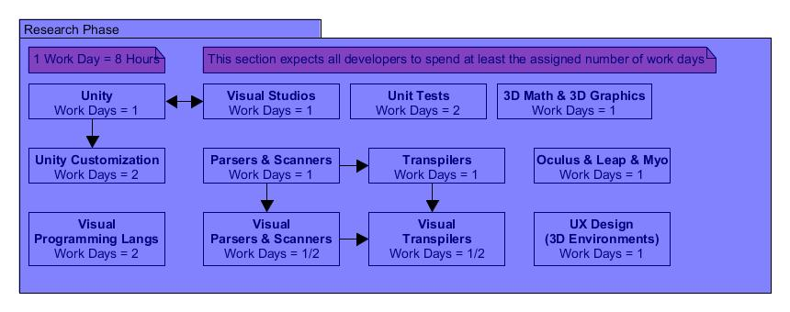
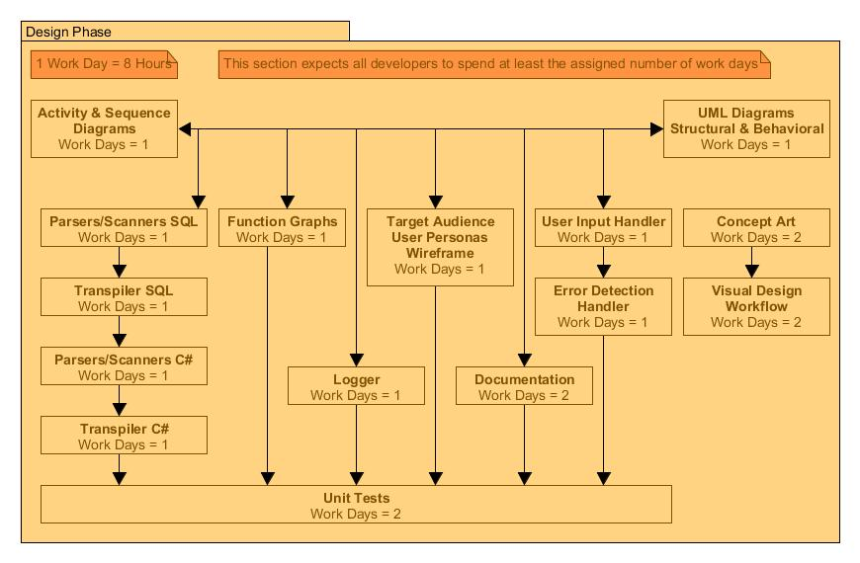
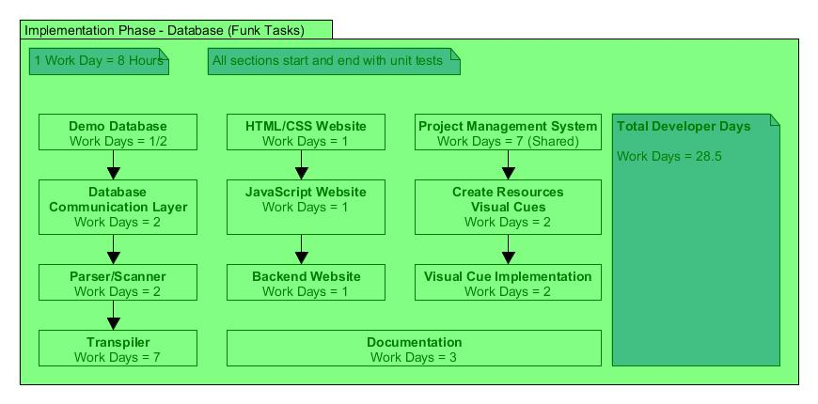
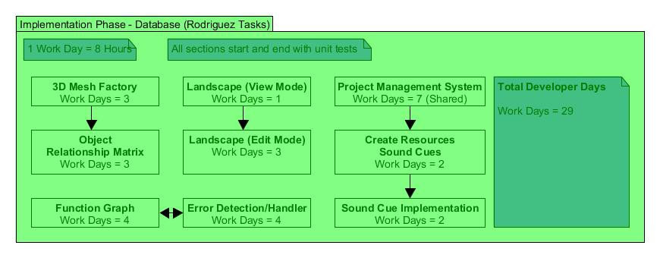
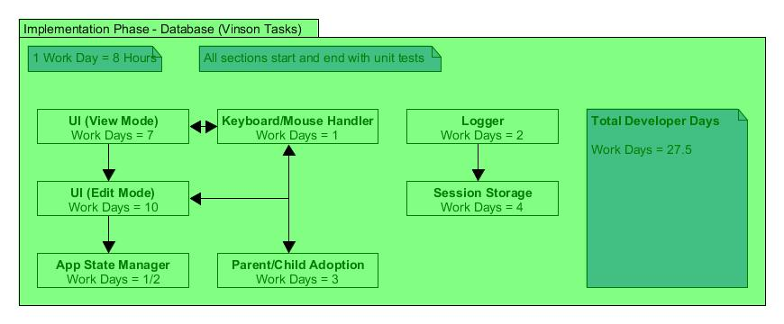
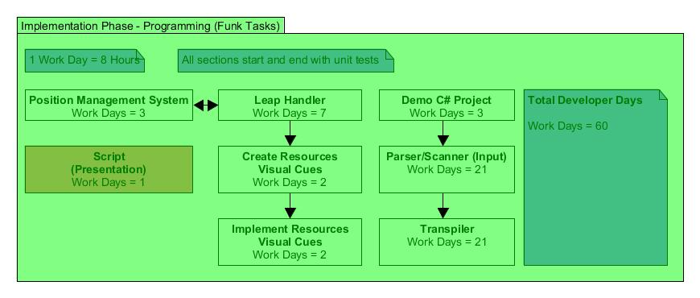
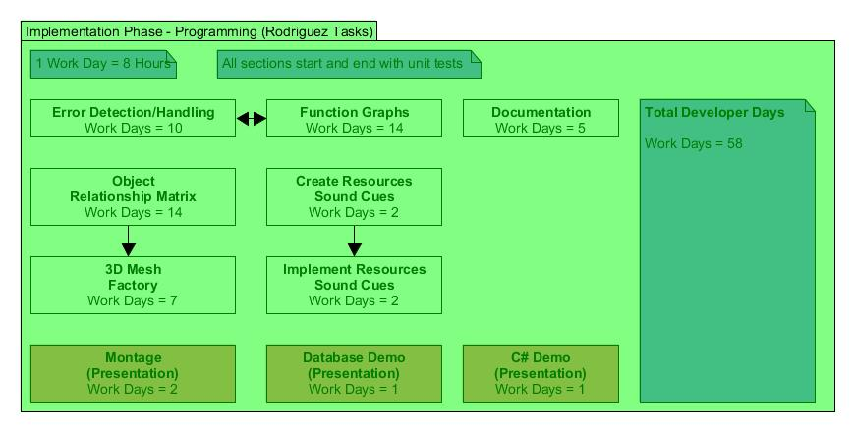
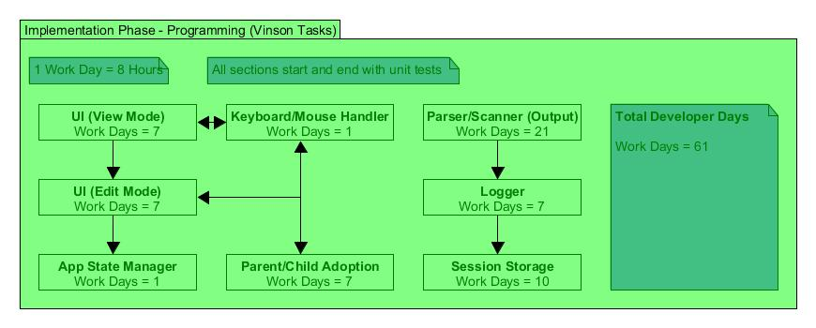

Illustration

Cost Projections

Assets Acquired

- Oculus Development Kit 2.0 --- $550.00
- Leap Motion Controller --- $30.00
- PS4 Controller --- $60.00
- XBOX One Controller --- $60.00
--------------------------------------------------------------------------------
$700.00

Projected Acquisitions

- 2nd Leap Motion Controller --- $30.00
- Code School Tutorials --- $50.00
- Leap Motion Keyboard --- $100.00
- Myo Band Controller --- $200.00
- 3D Assets --- $100.00
--------------------------------------------------------------------------------
$480.00

Projected Total

- All Assets --- $1180.00

Milestones

Research Phase

